Experiment No – 8
Title / Aim :- Access and validate form fields using events; design a gym admission form with live input checks.
Software/Tools Required :-
- Visual Studio Code (VS Code)
- Google Chrome / Any Web Browser
- HTML
- JavaScript

CODE:-
Index.html
<!DOCTYPE html>
<html lang="en">
<head>
<meta charset="UTF-8">
<meta name="viewport" content="width=device-width, initial-scale=1.0">
<title>F&Z Gym</title>
<link rel="stylesheet" href="style.css">
</head>
<body>
<div class="container">
<!-- HEADER -->
<header>
<div class="logo">🏋️ F&Z</div>
<p>BUILD YOUR BEST SELF</p>
</header>
<!-- MAIN CONTENT -->
<div class="main-section">
<!-- PERSONAL DETAILS -->
<section class="details">
<h2>👤 YOUR DETAILS</h2>
<label>Full Name</label>
<input type="text" id="name" placeholder="Enter your name">
<small id="nameMsg"></small>
<label>Email</label>
<input type="text" id="email" placeholder="Enter your email">
<small id="emailMsg"></small>
<div class="small-fields">
<div>
<label>Age</label>
<input type="number" id="age" placeholder="Age">
<small id="ageMsg"></small>
</div>
<div>
<label>Phone</label>
<input type="text" id="phone" placeholder="Phone number">
<small id="phoneMsg"></small>
</div>
</div>
</section>
<!-- MEMBERSHIP PLANS -->
<section class="plans">
<h2>💳 CHOOSE YOUR PLAN</h2>
<div class="plan-container">
<!-- BASIC -->
<div class="plan" data-plan="Basic">
<div class="plan-icon">🥉</div>
<h3>BASIC</h3>
<h4>₹999</h4>
<p>/ month</p>
<button type="button">SELECT</button>
</div>
<!-- PREMIUM -->
<div class="plan" data-plan="Premium">
<div class="plan-icon">🥈</div>
<h3>PREMIUM</h3>
<h4>₹1499</h4>
<p>/ month</p>
<button type="button">SELECT</button>
</div>
<!-- ELITE -->
<div class="plan" data-plan="Elite">
<div class="plan-icon">🥇</div>
<h3>ELITE</h3>
<h4>₹1999</h4>
<p>/ month</p>
<button type="button">SELECT</button>
</div>
</div>
<p id="selectedPlan">No plan selected</p>
</section>
</div>
<!-- LIVE VALIDATION -->
<section class="validation">
<h2>✓ LIVE VALIDATION</h2>
<div class="status">
<span id="nameStatus">Name ⏳</span>
<span id="emailStatus">Email ⏳</span>
<span id="ageStatus">Age ⏳</span>
<span id="phoneStatus">Phone ⏳</span>
</div>
<button id="joinBtn">JOIN NOW</button>
<p id="result"></p>
</section>
</div>
<script src="script.js"></script>
</body>
</html>

Script.js
// ACCESS HTML ELEMENTS
const nameInput = document.getElementById("name");
const emailInput = document.getElementById("email");
const ageInput = document.getElementById("age");
const phoneInput = document.getElementById("phone");

const nameMsg = document.getElementById("nameMsg");
const emailMsg = document.getElementById("emailMsg");
const ageMsg = document.getElementById("ageMsg");
const phoneMsg = document.getElementById("phoneMsg");

const nameStatus = document.getElementById("nameStatus");
const emailStatus = document.getElementById("emailStatus");
const ageStatus = document.getElementById("ageStatus");
const phoneStatus = document.getElementById("phoneStatus");

const plans = document.querySelectorAll(".plan");

const selectedPlan = document.getElementById("selectedPlan");
let plan = "";
// NAME VALIDATION
function checkName() {
if (nameInput.value.trim().length >= 3) {
nameInput.classList.add("valid");
nameInput.classList.remove("invalid");
nameMsg.textContent = "✓ Valid name";
nameMsg.style.color = "#16A34A";
nameStatus.textContent = "Name ✓";
return true;
} else {
nameInput.classList.add("invalid");
nameInput.classList.remove("valid");
nameMsg.textContent = "Enter at least 3 characters";
nameMsg.style.color = "#DC2626";
nameStatus.textContent = "Name ✕";
return false;
}
}
// EMAIL VALIDATION
function checkEmail() {
const emailPattern =
/^[^\s@]+@[^\s@]+\.[^\s@]+$/;
if (emailPattern.test(emailInput.value)) {
emailInput.classList.add("valid");
emailInput.classList.remove("invalid");
emailMsg.textContent = "✓ Valid email";
emailMsg.style.color = "#16A34A";
emailStatus.textContent = "Email ✓";
return true;
} else {
emailInput.classList.add("invalid");
emailInput.classList.remove("valid");
emailMsg.textContent = "Enter a valid email";
emailMsg.style.color = "#DC2626";
emailStatus.textContent = "Email ✕";
return false;
}
}
// AGE VALIDATION
function checkAge() {
const age = Number(ageInput.value);
if (age >= 16 && age <= 80) {
ageInput.classList.add("valid");
ageInput.classList.remove("invalid");
ageMsg.textContent = "✓ Valid age";
ageMsg.style.color = "#16A34A";
ageStatus.textContent = "Age ✓";
return true;
} else {
ageInput.classList.add("invalid");
ageInput.classList.remove("valid");
ageMsg.textContent = "Age must be between 16 and 80";
ageMsg.style.color = "#DC2626";
ageStatus.textContent = "Age ✕";
return false;
}
}
// PHONE VALIDATION
function checkPhone() {
const phonePattern = /^[0-9]{10}$/;
if (phonePattern.test(phoneInput.value)) {
phoneInput.classList.add("valid");
phoneInput.classList.remove("invalid");
phoneMsg.textContent = "✓ Valid phone number";
phoneMsg.style.color = "#16A34A";
phoneStatus.textContent = "Phone ✓";
return true;
} else {
phoneInput.classList.add("invalid");
phoneInput.classList.remove("valid");
phoneMsg.textContent = "Enter 10 digit phone number";
phoneMsg.style.color = "#DC2626";
phoneStatus.textContent = "Phone ✕";
return false;
}
}
// LIVE INPUT EVENTS
nameInput.addEventListener("input", checkName);
emailInput.addEventListener("input", checkEmail);
ageInput.addEventListener("input", checkAge);
phoneInput.addEventListener("input", checkPhone);
// FOCUS EVENT
nameInput.addEventListener("focus", function() {
nameMsg.textContent = "Enter your full name";
nameMsg.style.color = "#64748B";
});
// MEMBERSHIP PLAN SELECTION
plans.forEach(function(card) {
const button = card.querySelector("button");
button.addEventListener("click", function() {
// Remove selected class
plans.forEach(function(item) {
item.classList.remove("selected");
});
// Select current card
card.classList.add("selected");
// Get selected plan
plan = card.getAttribute("data-plan");
selectedPlan.textContent =
"Selected Plan: " + plan;
});
});
// JOIN BUTTON
document.getElementById("joinBtn").addEventListener("click", function() {
const validName = checkName();
const validEmail = checkEmail();
const validAge = checkAge();
const validPhone = checkPhone();
if (
validName &&
validEmail &&
validAge &&
validPhone &&
plan !== ""
) {
document.getElementById("result").textContent =
"🎉 Registration Successful! Welcome to FitZone.";
document.getElementById("result").style.color =
"#16A34A";
} else {
document.getElementById("result").textContent =
"⚠️ Please complete all details correctly.";
document.getElementById("result").style.color =
"#DC2626";
}
});

Style.css
/* RESET */
* {
box-sizing: border-box;
margin: 0;
padding: 0;
}
/* BODY */
body {
font-family: Arial, sans-serif;
background: #0F172A;
min-height: 100vh;
padding: 40px 20px;
}
/* MAIN CONTAINER */
.container {
max-width: 1000px;
margin: auto;
background: #FFFFFF;
border-radius: 18px;
overflow: hidden;
box-shadow: 0 10px 30px rgba(0, 0, 0, 0.3);
}
/* HEADER */
header {
background: #0F172A;
color: #FFFFFF;
text-align: center;
padding: 30px;
}
.logo {
font-size: 32px;
font-weight: bold;
color: #FFFFFF;
}
header p {
margin-top: 8px;
color: #A78BFA;
letter-spacing: 3px;
font-size: 13px;
}
/* MAIN SECTION */
.main-section {
display: grid;
grid-template-columns: 1fr 1.4fr;
gap: 35px;
padding: 40px;
background: #F8FAFC;
}
/* DETAILS AND PLANS */
.details,
.plans {
background: #FFFFFF;
padding: 25px;
border-radius: 14px;
box-shadow: 0 3px 10px rgba(0, 0, 0, 0.08);
}
h2 {
color: #1E293B;
font-size: 20px;
margin-bottom: 25px;
}
/* INPUT FIELDS */
label {
display: block;
margin-top: 15px;
margin-bottom: 7px;
font-weight: bold;
color: #1E293B;
}
input {
width: 100%;
padding: 12px;
border: 2px solid #E2E8F0;
border-radius: 8px;
font-size: 15px;
color: #1E293B;
background: #FFFFFF;
}
input:focus {
outline: none;
border-color: #7C3AED;
box-shadow: 0 0 0 3px rgba(124, 58, 237, 0.1);
}
/* SMALL FIELDS */
.small-fields {
display: grid;
grid-template-columns: 1fr 1.5fr;
gap: 15px;
}
/* VALIDATION MESSAGE */
small {
display: block;
min-height: 18px;
margin-top: 5px;
font-size: 12px;
}
/* MEMBERSHIP PLAN */
.plan-container {
display: flex;
gap: 15px;
}
.plan {
flex: 1;
text-align: center;
border: 2px solid #E2E8F0;
border-radius: 12px;
padding: 20px 10px;
background: #FFFFFF;
transition: 0.2s;
}
.plan:hover {
border-color: #7C3AED;
transform: translateY(-3px);
}
.plan.selected {
border-color: #7C3AED;
background: #F3E8FF;
box-shadow: 0 4px 12px rgba(124, 58, 237, 0.15);
}
.plan-icon {
font-size: 28px;
margin-bottom: 8px;
}
.plan h3 {
color: #1E293B;
margin-bottom: 10px;
font-size: 16px;
}
.plan h4 {
color: #7C3AED;
font-size: 24px;
margin-bottom: 3px;
}
.plan p {
color: #64748B;
margin-bottom: 15px;
font-size: 13px;
}
/* PLAN BUTTON */
.plan button {
background: #0F172A;
color: #FFFFFF;
border: none;
padding: 8px 15px;
border-radius: 6px;
cursor: pointer;
font-weight: bold;
}
.plan button:hover {
background: #7C3AED;
}
/* SELECTED PLAN TEXT */
#selectedPlan {
text-align: center;
margin-top: 20px;
color: #7C3AED;
font-weight: bold;
}
/* VALIDATION SECTION */
.validation {
background: #FFFFFF;
border-top: 1px solid #E2E8F0;
padding: 30px;
text-align: center;
}
.validation h2 {
margin-bottom: 20px;
}
/* STATUS */
.status {
display: flex;
justify-content: center;
gap: 15px;
flex-wrap: wrap;
margin-bottom: 25px;
}
.status span {
padding: 8px 15px;
border-radius: 20px;
background: #F1F5F9;
color: #475569;
font-size: 14px;
}
/* JOIN BUTTON */
#joinBtn {
background: #7C3AED;
color: #FFFFFF;
border: none;
padding: 13px 40px;
border-radius: 8px;
font-size: 16px;
font-weight: bold;
cursor: pointer;
}
#joinBtn:hover {
background: #0F172A;
}
/* RESULT */
#result {
margin-top: 15px;
font-weight: bold;
}
/* VALID / INVALID */
.valid {
border-color: #16A34A !important;
}
.invalid {
border-color: #DC2626 !important;
}

Output
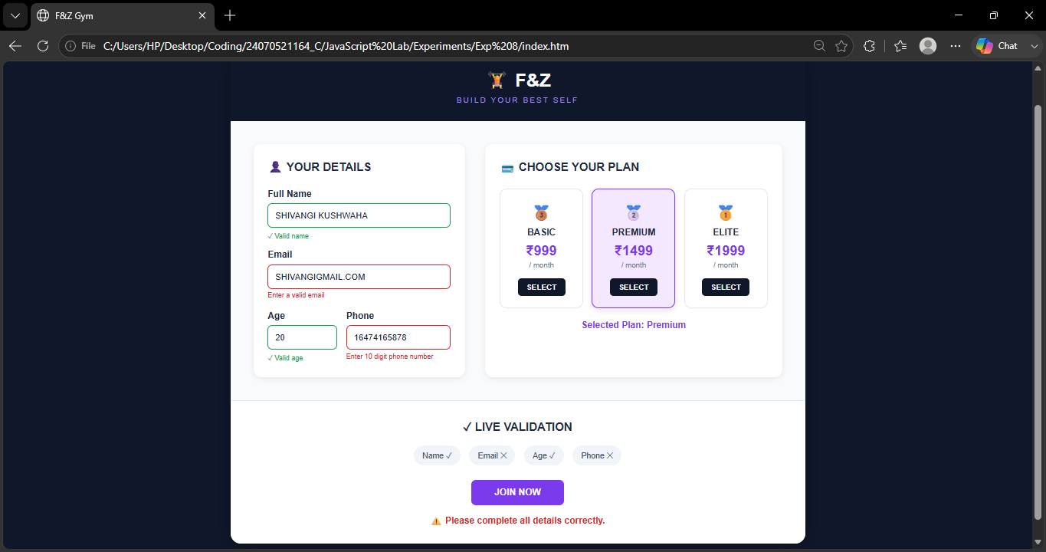

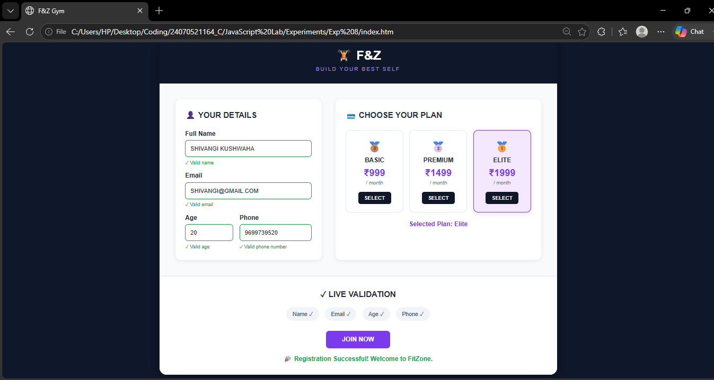

Result / Conclusion :-
The F&Z Gym Admission Form was successfully developed using HTML, CSS, and JavaScript. Live validation was implemented for the name, email, age, and phone number fields using JavaScript events. Different membership plans were displayed as interactive cards, allowing the user to select a plan. DOM manipulation and Regular Expressions were used for accessing fields and validating user input. Thus, the experiment provided practical understanding of form handling, event handling, DOM manipulation, and client-side validation in JavaScript.

